Experiment No. | 7
Aim | nQueens problem using Backtracking Strategy
Name | Sakshi D Lonare
UID No. | 2021300069
Class & Division | Comps SE A

Algorithm:-

-> 1) Start in the leftmost column
2) If all queens are placed
Print the solutions
return true
3) Try all rows in the current column.
Do following for every tried row.
a) If the queen can be placed safely in this row
then mark this [row, column] as part of the
solution and recursively check if placing
queen here leads to a solution.
b) If placing the queen in [row, column] leads to
a solution then return true.
c) If placing queen doesn't lead to a solution then
unmark this [row, column] (Backtrack) and go to
step (a) to try other rows.
4) If all rows have been tried and nothing worked,
return false to trigger backtracking.

Program:-
#include <stdio.h>
#include <stdbool.h>

int N;
int c=0;
void printBoard(int b[N][N]){
for(int i=0;i<N;i++)
{
for(int j=0;j<N;j++)
{
printf("%d\t",b[i][j]);
}
printf("\n");
}
}

bool ifSafe(int b[N][N],int row,int col)
{
int i,j;
for (i = 0; i < col; i++)//to check row on left side of col
if (b[row][i])
return false;

for (i = row, j = col; i >= 0 && j >= 0; i--, j--)//to check upper diagonal
if (b[i][j])
return false;

for (i = row, j = col; j >= 0 && i < N; i++, j--)//to check lower diagonal
if (b[i][j])
return false;

return true;
}

/*bool solvNQ(int b[N][N],int col)//prints one solution
{
if(col>=N)//if all queens are placed
{
c++;
printf("Solution %d:\n", c);
printBoard(b);
return true;
}

for(int i=0;i<N;i++)
{
if(ifSafe(b,i,col))
{
b[i][col]=1;//place the queen

if (solvNQ(b, col + 1))//recur to place all the queens
return true;

b[i][col]=0; //BACKTRACK i.e if queen cant be placed , no solution
}
}
return false; //no solution for the queens to be placed
}*/

void solvNQ(int b[N][N], int col, int* sols[][N])//to print all the solutions
{
if (col >= N) {
int (*sol)[N] = malloc(N * sizeof(*sol));
memcpy(sol, b, N * sizeof(*sol));
sols[c][0] = sol;
c++;
return;
}
for (int i = 0; i < N; i++) {
if (ifSafe(b, i, col)) {
b[i][col] = 1;
solvNQ(b, col + 1, sols);
b[i][col] = 0;
}
}
}

bool checkB()
{
int i;
printf("Enter the value of N:");
scanf("%d", &N);
int b[N][N];
int* sols[100][N];
for (i = 0; i < N; i++) {
for (int j = 0; j < N; j++) {
b[i][j] = 0;
}
}
solvNQ(b, 0, sols);
if (c == 0) {
printf("Solution does not exist");
return false;
}
printf("Number of solutions found: %d\n",c);
printf("Solutions:\n");
for (int k = 0; k < c; k++) {
printf("Solution %d:\n", k + 1);
int (*sol)[N] = sols[k][0];
for (i = 0; i < N; i++) {
for (int j = 0; j < N; j++) {
printf("%d ", sol[i][j]);
}
printf("\n");
}
printf("\n");
}
return true;
}
int main(){
checkB();
return 0;
}

Output:-
1)For N=6, 2 intermediate solutions
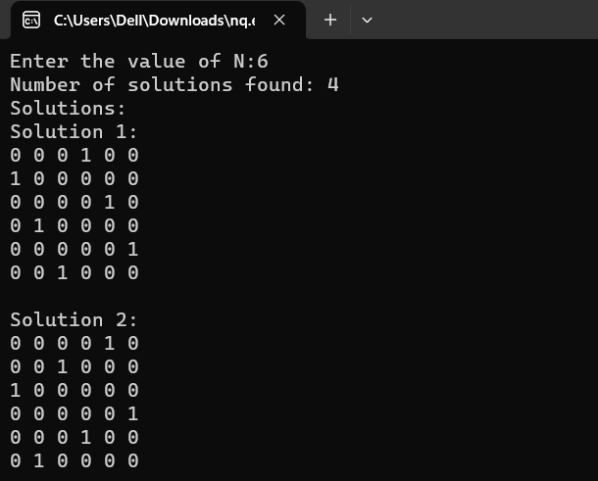

2)For N=8 and upto 5 solutions
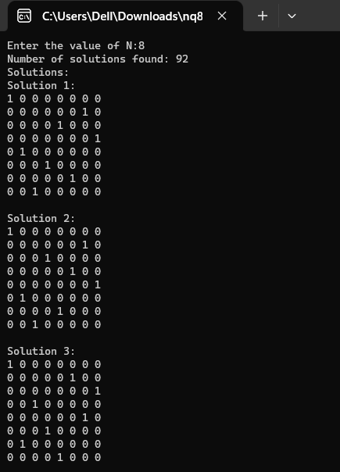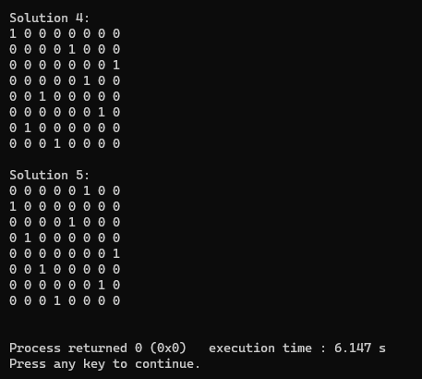

Conclusion: I learnt how to solve the nQueens problem using backtracking strategy. Backtracking is a useful strategy for solving certain types of problems, and understanding its principles and techniques can be helpful for problem-solving in general.

